Chapter 8: Basic Concepts of Chemical Bonding



# Section 1: Lewis Symbols and the Octet Rule



## How to draw Lewis Symbols

* The dots are placed on the four sides of the symbol-top,bottom,left and right- and each side can hold up to two electrons. All four sides are equivalent, which means that the choice of which sides to place two electrons rather than one electron is arbitrary. In general, we spread out the dots as much as possible.

## Octet Rule

* Due to the Octet rule, noble gases have very stable electron arrangements, as evidenced by their high ionization energies, low affinity for additional electrons, and general lack of chemical reactivity.
* All noble gases have 8 valence electrons except for Helium which has 2
* Many atoms undergoing reactions end up with eight valence electrons.
* An octet of electrons consists of full *s* and *p* subshells in an atom.
* In a Lewis symbol, an octet is shown as four pairs of valence electrons arranged around the element symbol.

# Section 2: Ionic Bonding



* Usually ionic bonding occurs between metals and nonmetals(excluding Noble Gases)
  + Example Na(s) + ½ Cl₂ (g) → NaCl(s) ∆H°𝑓 = -410.9 kJ
  + Explanation: Na(s) is brought in contact with chlorine gas, Cl₂(g), a violent reaction that is exothermic to create sodium chloride, NaCl(s).
    - Sodium chloride is composed of Na⁺ and Cl⁻ ions arranged in a three-dimensional array
    - This indicates an electron from the sodium atom was lost and gained by a chlorine atom --we say there has been an electron transfer from the Na atom to the Cl atom. This makes Cl and Na comply with the octet rule.
  + Know the difference between Ionization Energy(The ability to lose an e⁻) and Electron Affinity(The ability to gain an e⁻)
  + NaCl is a typical ionic compound because it consist of a metal with a low ionization energy and a nonmetal of high electron affinity.
* **Ionic Bond Properties**
  + Brittle
  + High melting points
  + Crystalline
    - Cleaved(break apart along smooth, flat surfaces)
* **Energetics of Ionic Bond Formation**
  + Exothermic Reaction:
    - Negative enthalpy -∆H
  + Endothermic Reaction:
    - Positive enthalpy +∆H
  + What factors make the formation of ionic compounds so exothermic?
    - When taking away an e⁻ from Na(g) to form Na⁺(g), it requires 496 kJ/mol making it an endothermic reaction
      * When taking away an electron it requires energy making it an endothermic reaction
    - When the electron transfers the e⁻ to the Cl atom it releases 349 kJ/Mol making it an exothermic reaction
      * When an electron is added, it gives off energy making it an exothermic reaction.
    - 496 - 349 = 147 kJ/mol. This would make it an endothermic process to the formation of sodium and chloride ions that are infinitely far apart- meaning that:
      * The positive energy charge assumes that the ions do not interact with each other, which is quite different from the situation in ionic solids
    - The reason why ionic compounds are stable is due to the attraction between ions of opposite charge.
      * This attraction draws the ions together(making ionic bonds) causing ions to form a solid array, or lattice.
    - NaCl(s) → Na⁺(g) + Cl⁻(g) ∆H[lattice] = +788 kJ/mol
      * Note: This process is highly endothermic.
        + The reverse process is therefore highly exothermic

∆H[lattice] = -788 kJ/mol

* + - * + The higher the lattice energy the higher the boiling point and harder to break the bond
  + Calculating the magnitude of the lattice energy
 $E{}_{el}=\frac{kQ{}_{1}Q{}_{2}}{d}$

   - * In this equation Q₁ & Q₂ are the charges on the particles in Coulombs with their signs
      * *d* is the distance between their centers in meters
      * *k* is a constant, 8.99 x 10⁹ J-m/C²
    - Indicates the attractive interaction between two oppositely charged ions increases as the magnitude of their charges increases and a the distance decreases.
    - Meaning, ***For a given arrangement of ions, the lattice energy increases as the charge on the ions increases and as their radii decrease.***

# Section 3: Covalent Bonding

* Tend to be gases, liquids and solids with low melting points
  + Examples: water and gasoline
* Many are pliable in their solid forms
  + Examples: Plastic bags and wax
* **A chemical bond formed by sharing pairs of electrons**
* The hydrogen molecule, H₂, provides the simplest example of a covalent bond.

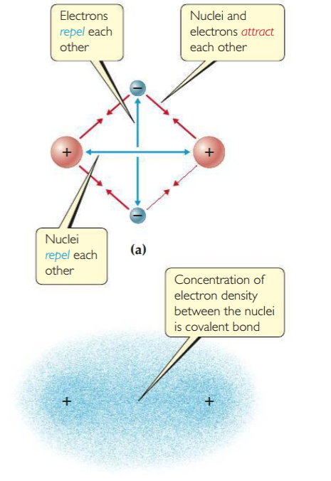

* A shared e⁻ pair is a single covalent bond
  + 2 would be a double bond
  + 3 would be a triple bond

# Section 4: Bond Polarity and Electronegativity



* Bond Polarity can be described as nonpolar, polar and ionic
* Electronegativity is used to estimate whether a given bond is nonpolar, polar and ionic.

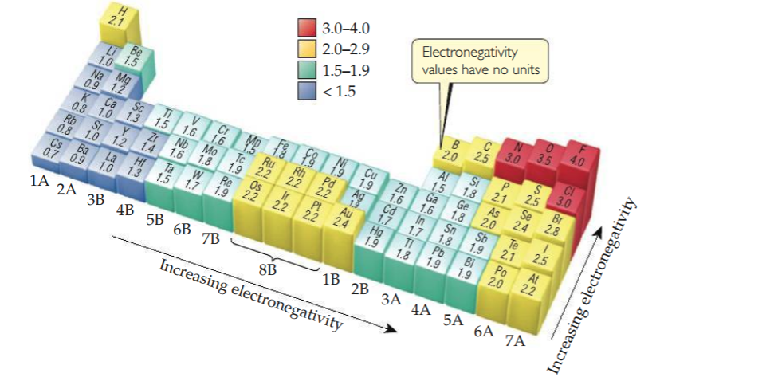

* Always one side with a partial charge(δ)
  + Negative or positive for atoms

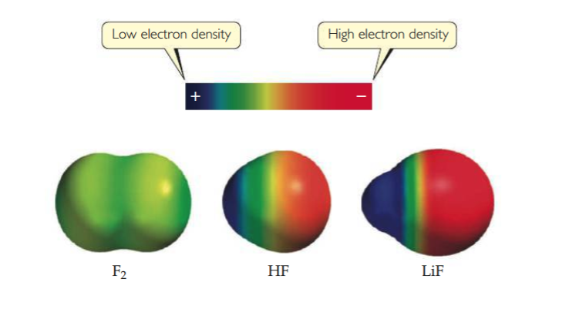

* **Dipole Moments**
  + Whenever two electrical charges of equal magnitude but opposite sign are separated by a distance, a dipole is established.
  + The quantitative measure of the magnitude of a dipole is called a dipole moment,denoted with the Greek letter mu, μ.
  + If two equal and opposite charges Q+ and Q- are separated by distance r
    - The magnitude of the dipole moment is the product of Q and r.
      * Μ = Qr
        + Expresion tells us that the dipole moment increases as the magnitude of Q increases and as r increases.
        + The larger the dipole moment, the more polar the bond.
        + If the dipole moment is zero, it is nonpolar due to the fact that there is no charge separation
    - Dipole moments are experimentally measurable and are usually reported in *debyes*(D), a unit that equals 3.34 x 10⁻³⁰ coulomb-meters(C*m).
    - For molecules, we measure charges in units of the electron charge *e*, 1.60 x 10⁻¹⁹ C
    - Distance(*r*) is measured in Angstroms( x 10⁻¹⁰ to convert from meters)

Insert mu equation here page 312

* Bonding between manganese and oxygen is not always ionic.
  + manganese(VII) oxide, Mn2O7, freezes at 5.9OC, an indication that covalen rather than ionic bonding domintes.
  + Metals with high oxidation states are covalent rather than ionic compounds
    - Examples: MnO4 and CrO42⁻

# Section 5: Drawing Lewis Structures



* **Drawing Lewis Dot Structures**

1. **Sum the valence electrons from all atoms, taking into account overall charge.**
2. **Write the symbols for the atoms, show which atoms are attached to which and connect them with a single bond(*a line, representing two electrons*)**
3. **Complete the octets around all the atoms bonded to the central atom.**
4. **Place any leftover electrons on the central atom**
5. **If there are not enough electrons to give the central atom an octet, try multiple bonds.**

* **Formal Charge and alternative Lewis Structures**
  + Formal charge is based off the electrons in the atom
    - How to calculate formal charge on any atom

1. *All* unshared ()

# Section 6: Resonance Structures



# Section 7: Exceptions to the Octet Rule



# Section 8: Strengths and Lengths of Covalent Bonds



# Definitions:



* **Section 1**

1. Valence Electrons ~
2. Lewis Dot Symbol ~
3. Octet Rule ~ Atoms tend to gain, lose, or share electrons until they are surrounded by eight valence electrons.

* **Section 2**

1. Lattice Energy ~ The energy required to completely separate one mole of a solid ionic compound into its gaseous ions.
2. Born-Haber cycle ~

* **Section 3**

1. Lewis Structures ~
2. Non-Bonding Pairs ~
3. Single Bond ~
4. Double Bond ~
5. Triple Bond ~

* **Section 4**

1. Bond Polarity ~ is a measure of how equally or unequally the e⁻ in any covalent bond are shared.
2. Nonpolar covalent bond ~ one in which the electrons are shared equally, as in Cl₂ and Na₂
3. Polar covalent bond ~ one of the atoms exerts a greater attraction for the bonding electrons than the other.
4. Electronegativity ~
5. Polar Molecule ~
6. Dipole ~
7. Dipole Moment ~

* **Section 5**

1. Formal Charge

* **Section 6**

1. l

* **Section 7**

1. l

* **Section 8**

1. l

# Equation Help:

